***"Mapping of all ERDs in Week 1"  
1*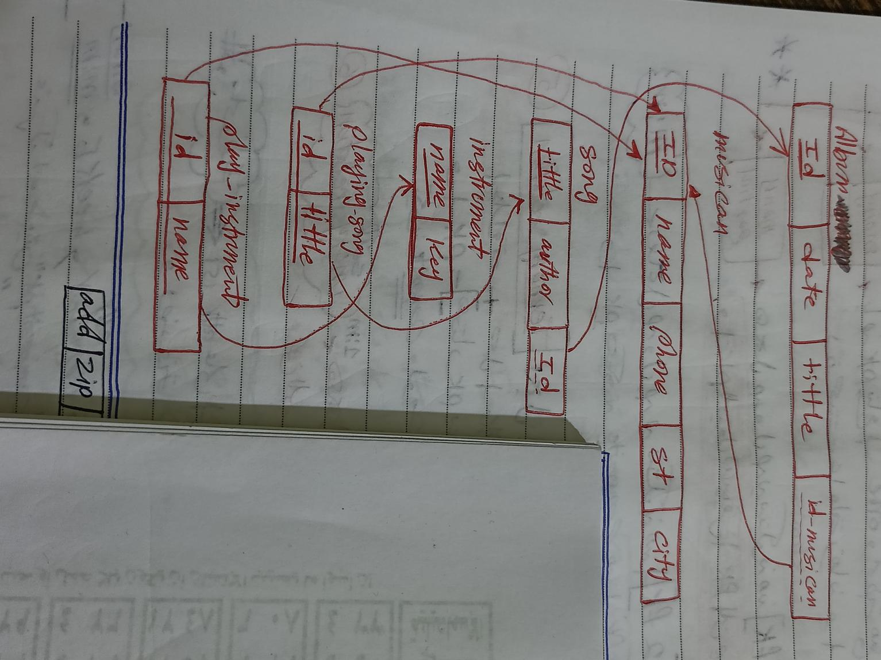 *2  
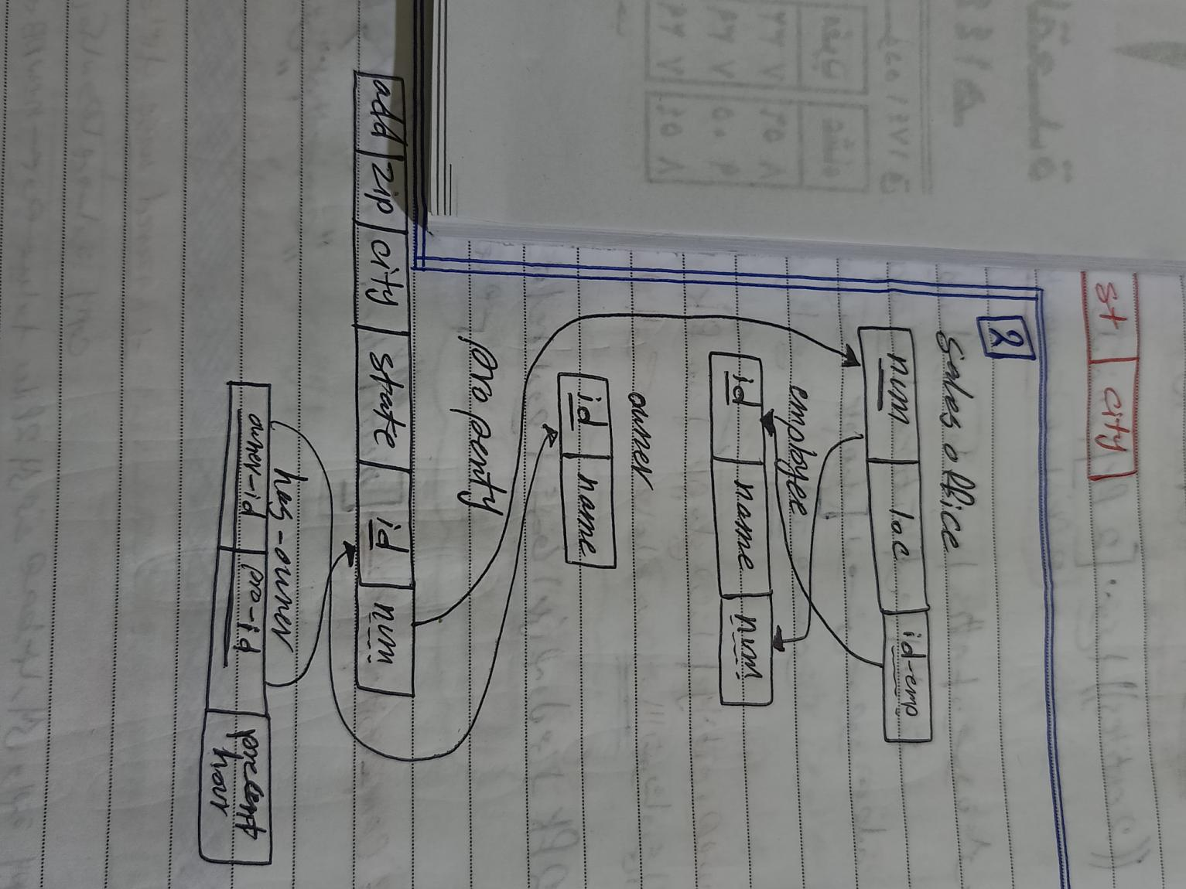  
  
  
  
3  
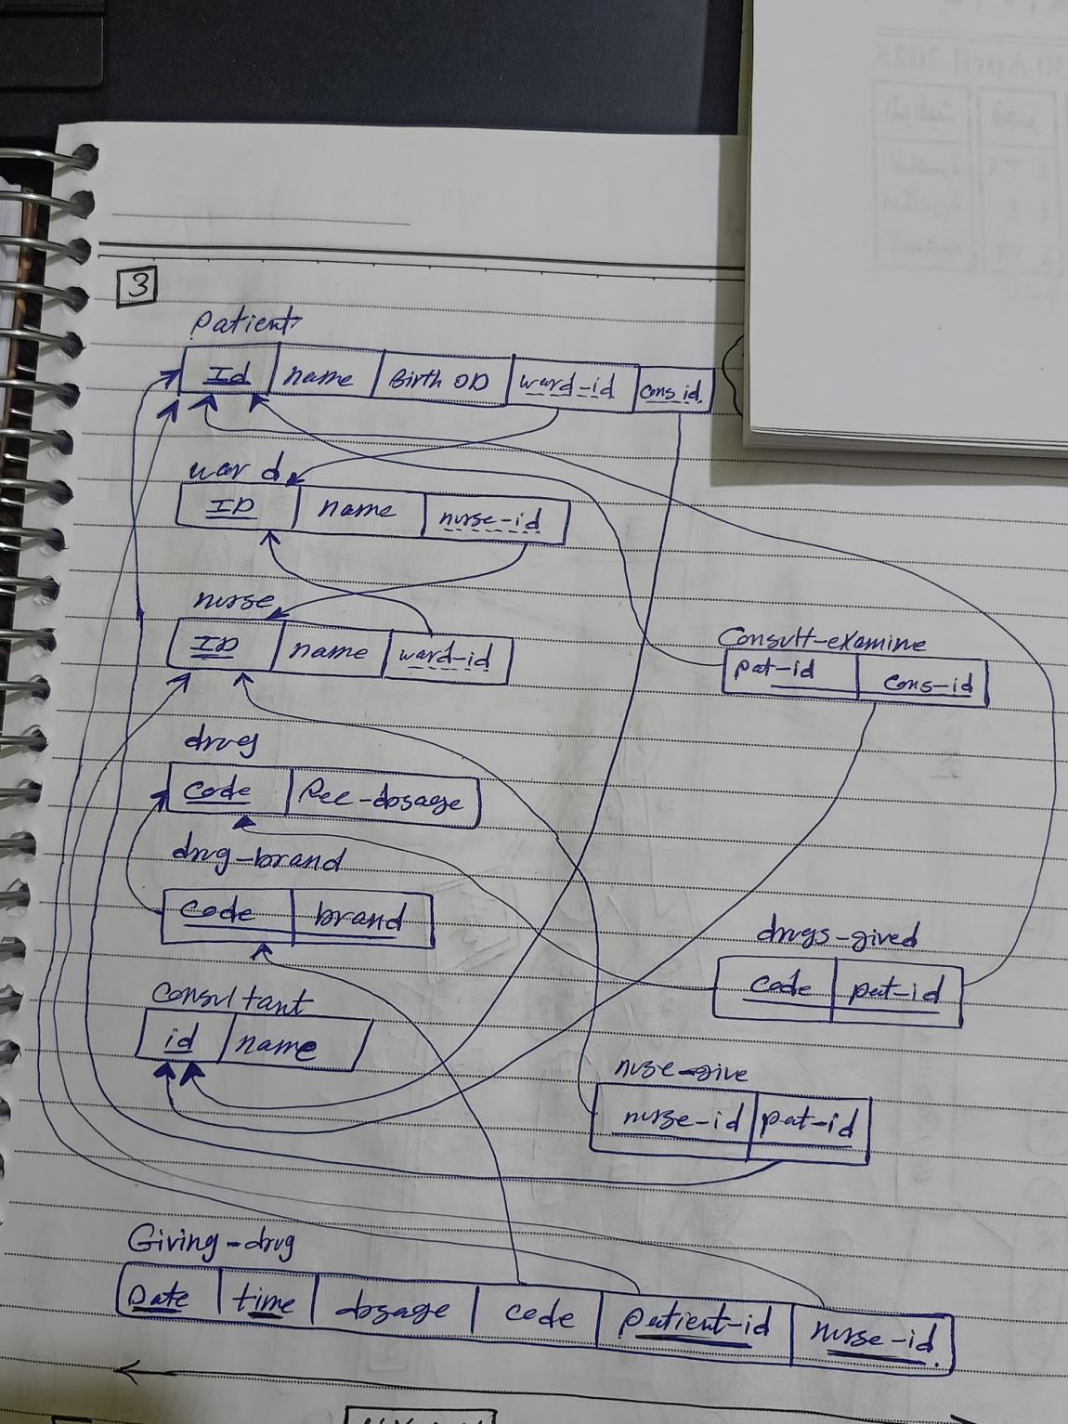  
  
  
  
4  
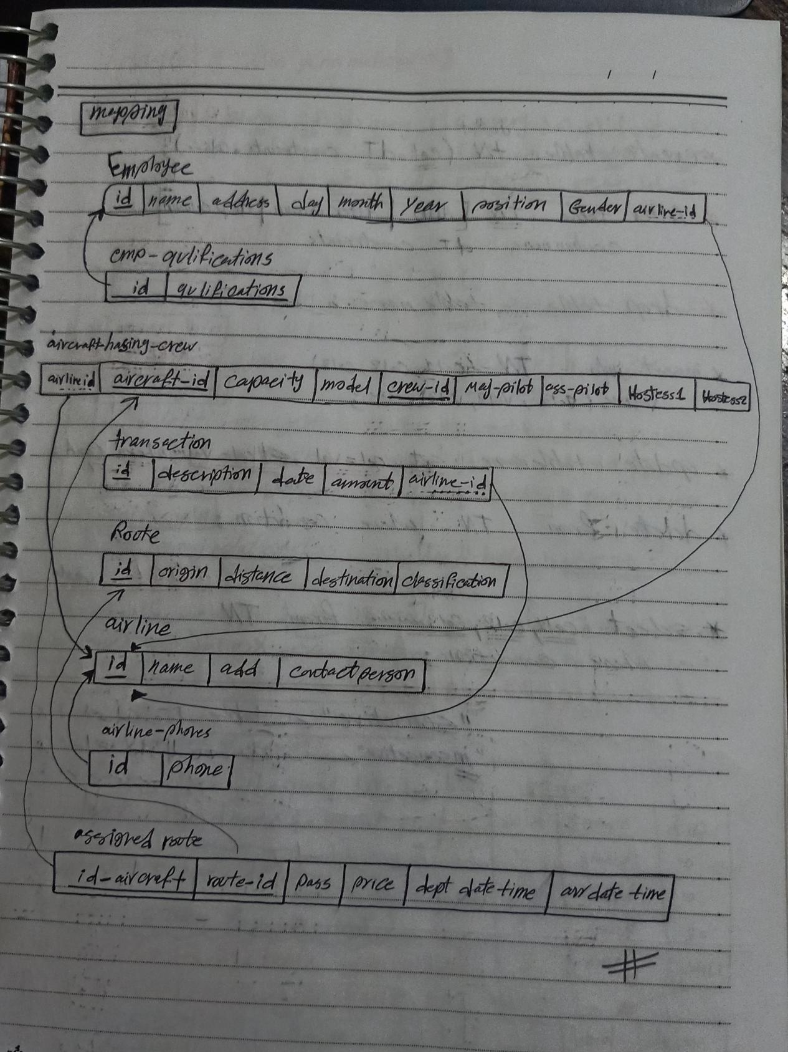  
 Day 2 done  
==========================***